FEDRAL BOARD OF INTERMEDIATE AND SECONDRY EDUCATION ISLAMABAD

RESULT CANCELATION CERTIFICATE

The result of ABDUL QAYYUM KHAN S / D / O KARIM KHAN MARWAT

______________________ ________________________

Bearing Roll no. 100093 and Registration No. 9010110004

___________ _______________

Who appeared in SSC-1 Annual Examination 2021 is hereby cancelled

On his / her own request. He / She is allowed to appear in the coming

SSC-1 / SSC-1&11 Annual Examination, if otherwise eligible.

Dated 2022-09-22 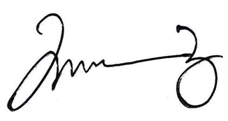 ______________

CONTROLLER OF EXAMINATION